Assignment # 02

**Submitted by: Noman amjad**

**Arid No: 21-ARID-654**

**Section: BSCS 3B**

**Submitted to: Miss.Marya**

**DATE: 20-09-2022**

**QUESTION:**

Identify process model. And write functional and non-functional requirements of this system.

**HOTEL MANAGEMENT SYSTEM:**

**ANSWER:**

The process model used in it is **WATER FALL PROCESS MODEL**.

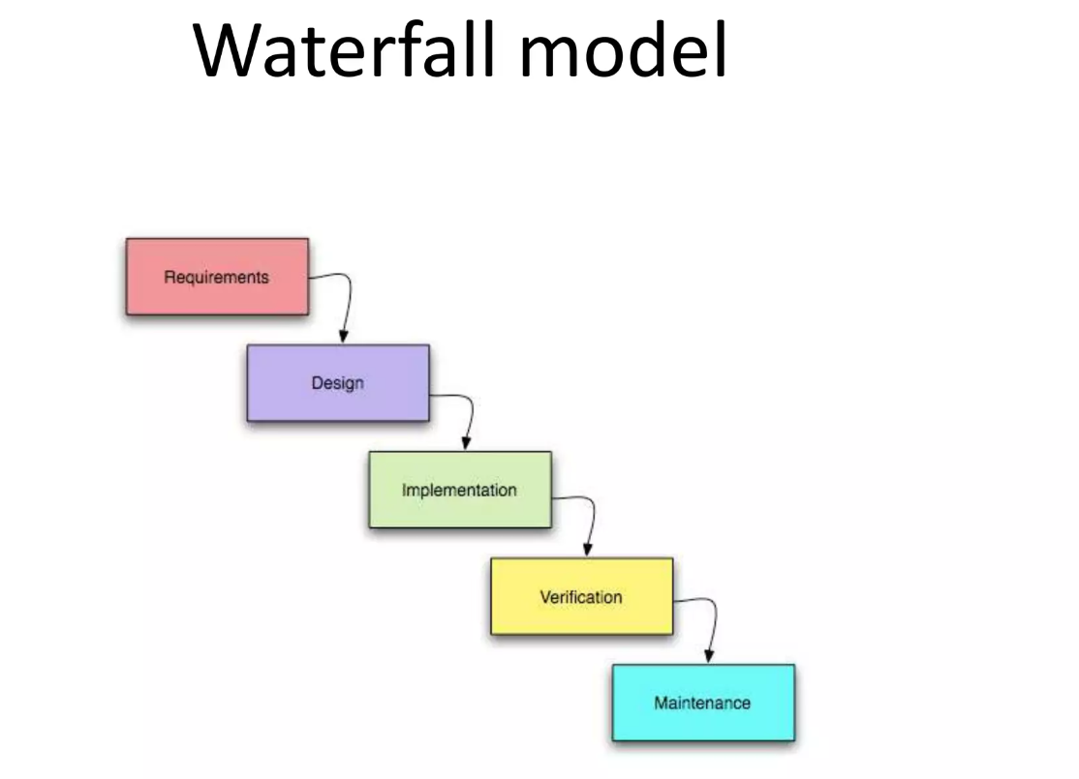

**Functional Requirements:**

**Make Reservation**

|  |  |
| --- | --- |
| **Input**:  Member Code, Total Persons, Check-in date, Check-out Date, status, number of nights. | **Output:**  Database Record, Database fully pop-up.  -Work Flow: Validate the given details and record the information in to the database. |

**Search Rooms**

|  |  |
| --- | --- |
| **Input**:  Period, Check-in, Check-out, Guest | **Output**:  Display a pop-up with available room details.  -Workflow: Validate the given details and check for the available rooms in the given time period. |

**Add Payment**

|  |  |
| --- | --- |
| **Input:**  Total, Pay time, credit card details. | **Output:**  Database Record, Database successfully updated pop-up.  -Workflow: Validate the given details and record the information in to the database |

**Issue Bills**

|  |  |
| --- | --- |
| **Input:**  Billing no, Quantity, Price, Taxes, Date, Services, unit. | **Output:**  Printed version of the bill.  -Workflow: Validate the given details and total cost is  calculated according to the services gained by the  customer. |

**Manage Guest (Add, Update, Delete)**

|  |  |
| --- | --- |
| **Input:**  Member Code, Contact, Name, Company, Email, Gender, Address. | **Output:**  Database Record. Database fully bon-up.  Workflow: Validate the given details and record the information in to the database. |

**Manage Room Detail (Add, Update, Delete)**

|  |  |
| --- | --- |
| **Input:**  Room no, Availability. | **Output:**  Database Record, Database fully pop-up.  Workflow: Validate the given details and record the information in to the database. |

**Manage Staff (Add, Update, Delete, View)**

|  |  |
| --- | --- |
| **Input:**  Employee Code, Employee Name, Employee Address, NIC, Salary, Age, Occupation, Email. | **Output:**  Database Record, Database successfully updated pop-Ur  Workflow: Validate the given details and record the information in to the database. |

**Non-functional prerequisites**

• Use encryption to avoid bots from booking

• Search results should populate within acceptable time limits

• Users should be helped appropriately to fill in the mandatory fields, in case of invalid input

• System should accept payments via various payment methods

• Easy to use, efficient, and accessible

• Keep track of documentation, activities, and responses

**Safety prerequisites**

In the hotel management system, there are various user levels. There will be a user login screen that requires a username and password to access the different subsystems. This provides a system view and user-level functions that are accessible.

**Security prerequisites**

The owner, managers, and representatives of customer service will have access to the Hotel Management System. The reservation/booking system and its subsystems will be accessible to customer service professionals. Both the reservation/booking and administration platforms will be accessible to managers. Owners have complete access to all subsystems. There will be a user login screen that requires a username and password to access the different subsystems.